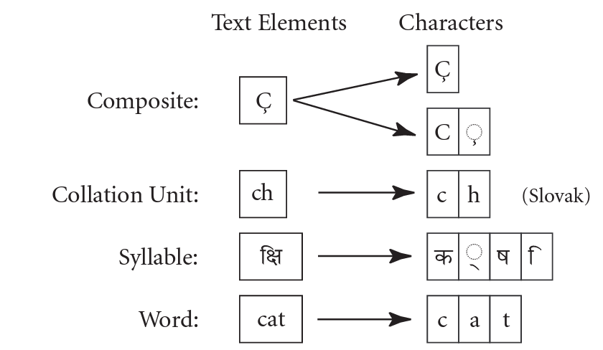

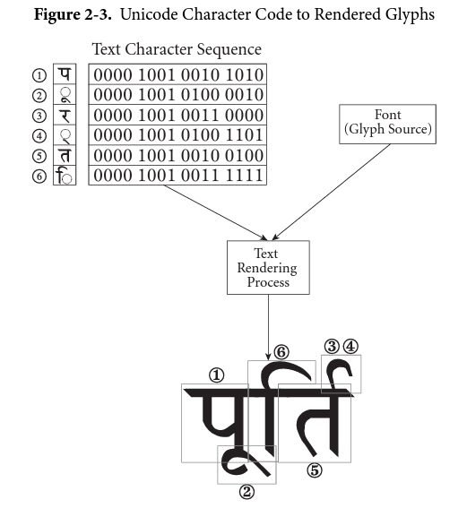

Plain text

Plain text is a pure sequence of character codes; plain Unicode-encoded text is therefore a sequence of Unicode character codes.

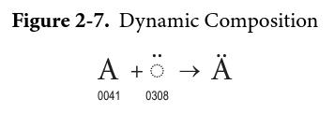

The variety of these end-user-perceived characters is quite great—particularly for digraphs, ligatures, or syllabic units. Furthermore, it depends on the particular language and writing system that may be involved. Despite this variety, however, the core concept “characters that should be kept together” can be defined for the Unicode Standard in a language-independent way. This core concept is known as a grapheme cluster. A grapheme cluster consists of a base character followed by any number of continuing characters, where a continuing character may include any nonspacing combining mark, certain spacing combining marks, or a join control.

<https://www.unicode.org/versions/Unicode15.0.0/bookmarks.html>

http://www.unicode.org/charts/

<https://unicodebook.readthedocs.io/>

<https://www.compart.com/en/unicode/>

🐱‍👤🥷🏻🥷🏿🐈‍⬛🐈‍⬛

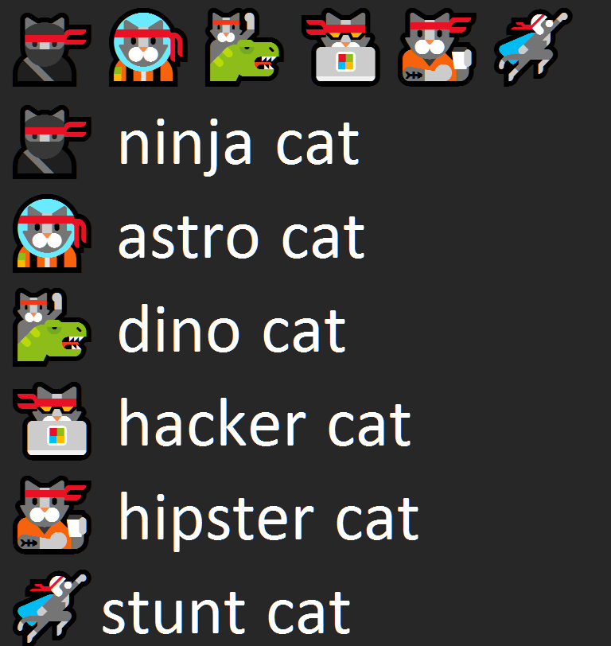

Wingdings U+F8FF

U+F800 BASKERVILLE OLD FACE 

U+F8FF CHIRP FONT 

<!-- Note that this Pen's settings include Font Awesome stylesheet! -->

<link rel="stylesheet"

href="https://maxcdn.bootstrapcdn.com/font-awesome/4.7.0/css/font-awesome.min.css">

<p><b>Apple Watch</b> (stylized as <i class="fa fa-apple" aria-hidden="true" title="Apple"></i>WATCH) is ...</p>

<p>The Windows Logo (printed as <i class="fa fa-windows" aria-hidden="true" title="Windows logo"></i>) is ...</p>

🐱‍👤🐱‍🚀🐱‍🐉🐱‍💻🐱‍👓🐱‍🏍

🐱‍👤 ninja cat

🐱‍🚀 astro cat

🐱‍🐉 dino cat

🐱‍💻 hacker cat

🐱‍👓 hipster cat

🐱‍🏍 stunt cat

<https://learn.microsoft.com/en-us/windows/win32/intl/character-sets-used-in-file-names>

